eCMS MANUAL

DECLARATION

Department of Revenue and Customs
Ministry of Finance

Table of Contents
1. Introduction 2
2. Login as Front-end user 2
3. Declaration 2
3.1 Search Async Declaration: 3
3.2 Search and Edit Declaration: 3
3.3 Create Declaration 4
3.4 Search Amendment Request 8
3.5 Create Amendment Request 8
3.6 Search Cancellation 9
3.7 Create Cancellation 9
3.8 Search Transit Amendment 9
3.9 Create Transit Amendment 9
3.10 Search Post Entry Declaration 10
3.11 Search Post Entry Cancellation 10
3.12 Create Post Entry Cancellation 10
4. Track Application 11
5. Search amendment request 11
6. Create Amendment request 11
7. Search Cancellation 12
8. Create Cancellation 12

Introduction

The declaration submission is the first step in the eCMS System. After submission, the declaration goes through processing by various department of Customs. This document also illustrates the overall processing of the various regimes supported by eCMS.

Login as Front-end user

- The user needs to log into eCMS using the url: www.ecms.gov.bt

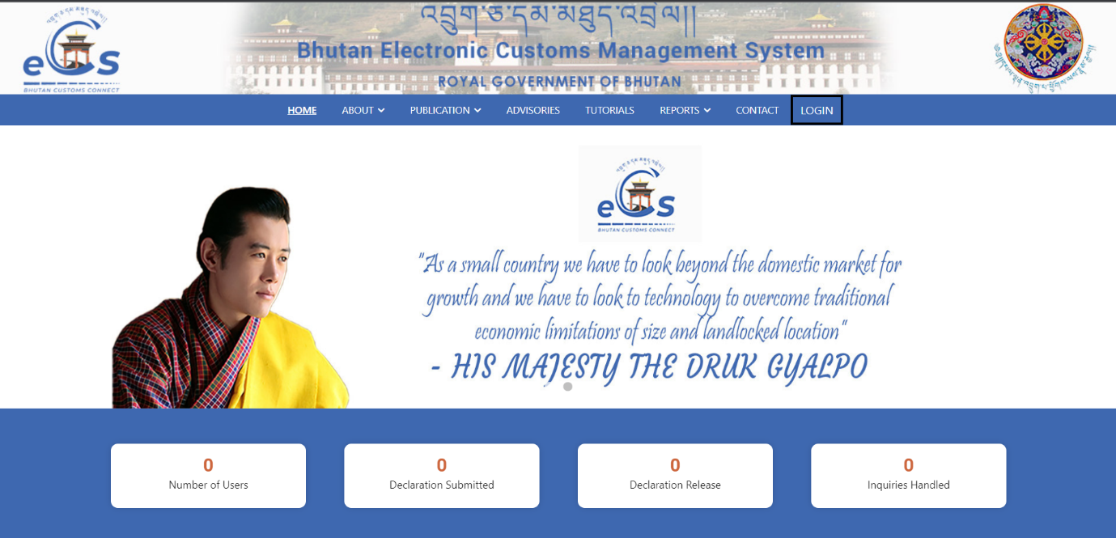

- Click on login menu and provide the required credentials to log in to the system:

Declaration

- Select Declaration FE for the list of menus provided in the dashboard:

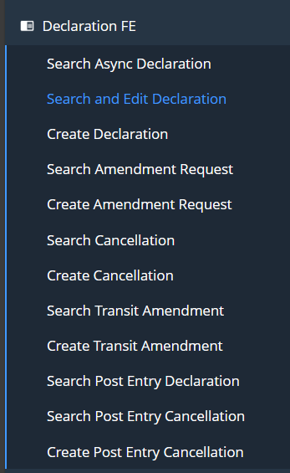

Search Async Declaration:
- provides list of declaration that has been created, submitted from the initial to till date by the user for a particular party.

Search and Edit Declaration:
- Provided the list for the following:
- Submitted Declaration list: list of declaration that has been submitted by the FE user.
- Draft declaration list: list of declaration that’s in draft state.

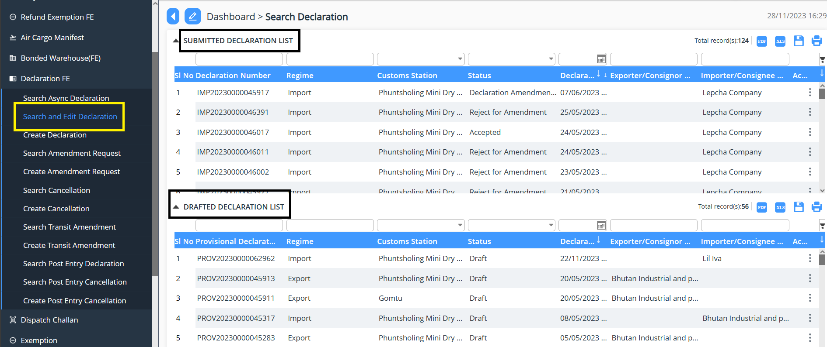

Create Declaration
- Allows the user to create the declaration by selecting different regime. 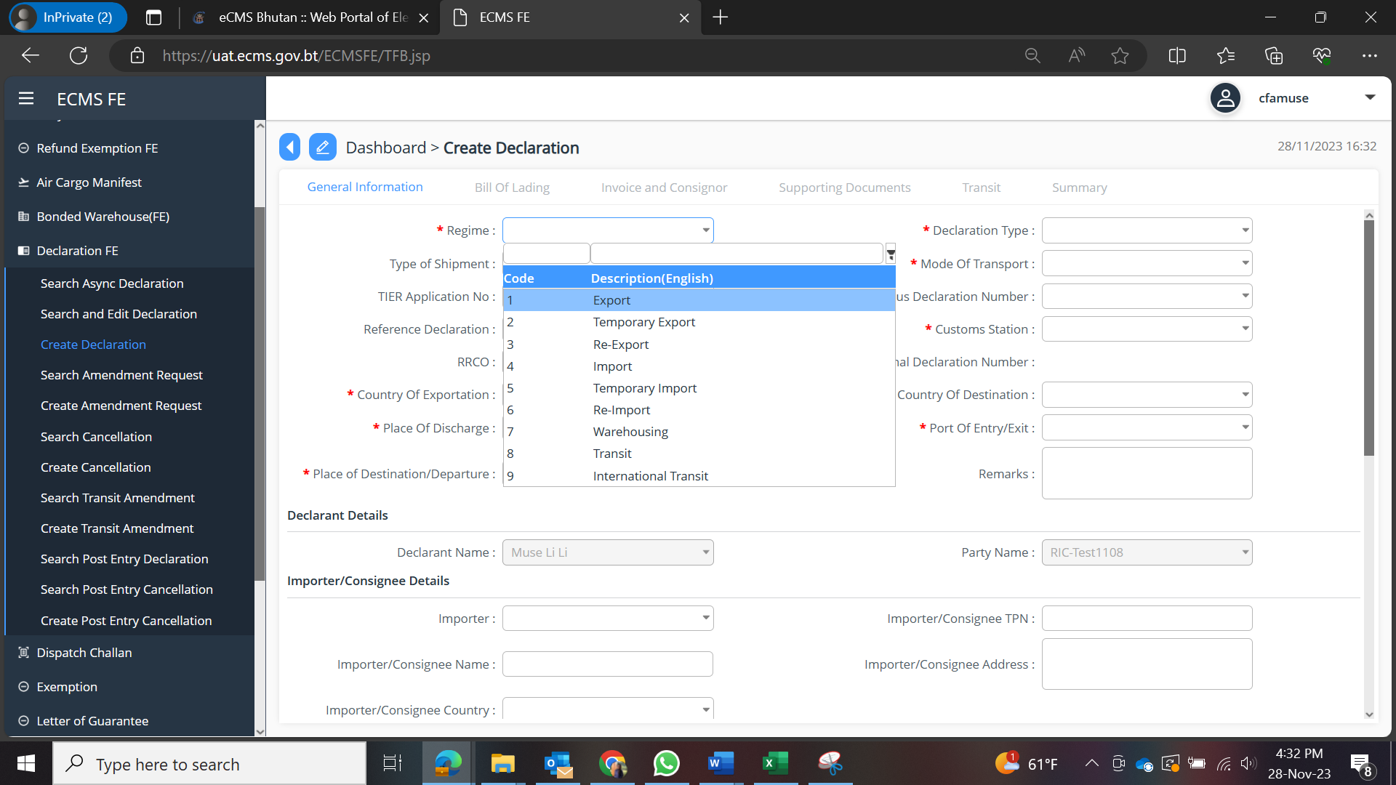
- Once the regime is selected accordingly Declaration Type for each regime is populated.
- Selection of declaration type based on the regime selected.
- Continue with the filling of details in each tab.
- The regime and their declaration type are as follows:

Sl no. | Regime | Declaration Type
 | Import | Direct Entry for Home Use
 |  | Entry for Home use after Temporary Admission
 |  | Entry for Home use after Warehousing (Ex-Warehousing)
 |  | Import for Home use after National Transit
 |  | Import for Home use after International Transit
 |  | Import for Home use after Inland Transit
 |  | Simplified Declaration
 |  | Duty free stores entry for home use
 |  | Duty free stores entry for home use without Customs Duty
 |  | Post Parcel after Transit
 |  | Import after Temporary Export for additional item
 |  | Entry for home use after export of Faculty goods
 |  | Direct Import (Discount)
 |  | Simplified Declaration for passenger Baggage with Exemption
 |  | Simplified Declaration for Offence
 |  | Post Parcel Commercial Goods
 |  | Post Parcel Commercial after transit
 |  | Passenger Baggage
 |  | Post Parcel Commercial after Warehouse
 |  | Duty Free Airline for Consumption
 |  | Duty Free sales for Quota Holder
 |  | Import of Diplomatic bags/VIP/Sample
 |  | Duty Free Sales from Airport
 |  | Duty Free Sales for non-Quota Holder
 |  | Import of Diplomatic bags/VIP/Sample after warehouse
 |  | Vehicle Import (Depreciation)
 |  | Post Parcel with Allowance
 |  | Third Country Origin Goods
 | Export | Direct/permanent Export
 |  | Permanent Export after Temporary Export of goods, an unaltered state
 |  | Export following entry for home use (under faculty condition)
 |  | Permanent Export after warehousing procedure
 |  | Export for International Transit
 |  | Special Export
 |  | Export of Mineral product to India
 | Temporary Import | Temporary Admission of return of goods, an unaltered state
 |  | Temporary Admission of return of goods, an unaltered state after warehousing
 |  | Temporary Admission from International Transit Declaration
 |  | Temporary Admission from National Transit Declaration
 |  | Transfer of Temporary Admission
 |  | Temporary Import for Passenger Baggage
 |  | Temporary Admission after inland transit
 |  | Temporary Admission of return of goods, an unaltered state (for trade exhibition related consignment)
 | Temporary Export | Temporary Export for return of goods(replacement)
 |  | Temporary Export (Repair and maintenance)
 |  | Temporary Export after warehousing for return unaltered state
 |  | Temporary Export for passenger baggage
 |  | Temporary Export for return of goods (Trade Fair/ Exhibition/Business Expo)
 | Re-Import | Re-import after Temporary export for return of goods an unaltered state
 |  | Re-import after Temporary Export for passenger baggage
 |  | Re-import after Temporary Export for return of goods(replacement)
 |  | Re-import after Temporary Export (repair and replacement)
 | Re-Export | Re-export after Temporary Admission for return an unaltered state
 |  | Re-export after customs warehousing procedure
 |  | Re-export goods bought by Diplomats at the end tenure
 |  | Re-export after temporary import for passenger baggage
 | Warehousing | Direct entry for warehousing procedure
 |  | Warehousing after temporary export for return of goods for replacement
 |  | Entry for warehousing after temporary admission
 |  | Entry for warehousing after International Transit
 |  | Entry for warehousing after National Transit
 |  | Entry for warehousing after Inland Transit
 |  | Transfer from one warehouse to another warehouse
 |  | Entry for Duty Free/Airlines Warehouse
 | Transit | National transit movement (India Territory without HScode)
 |  | National transit movement (India Territory after warehousing)
 |  | National transit movement from International Transit
 |  | Inland transit movement without HScode
 |  | Inland transit movement with HScode
 |  | Inland transit movement from International Transit
 |  | Inland transit after warehouse
 | International Transit | International Transit Movement (Kolkata/Bangladesh/Nepal)
- Based on the selection of the regime and declaration type the different tab details needs to be filled in.

  - General Information:
    - Select the Regime as Import >> Select Declaration type as per the requirement and get the details filled and save the data that has been completed.

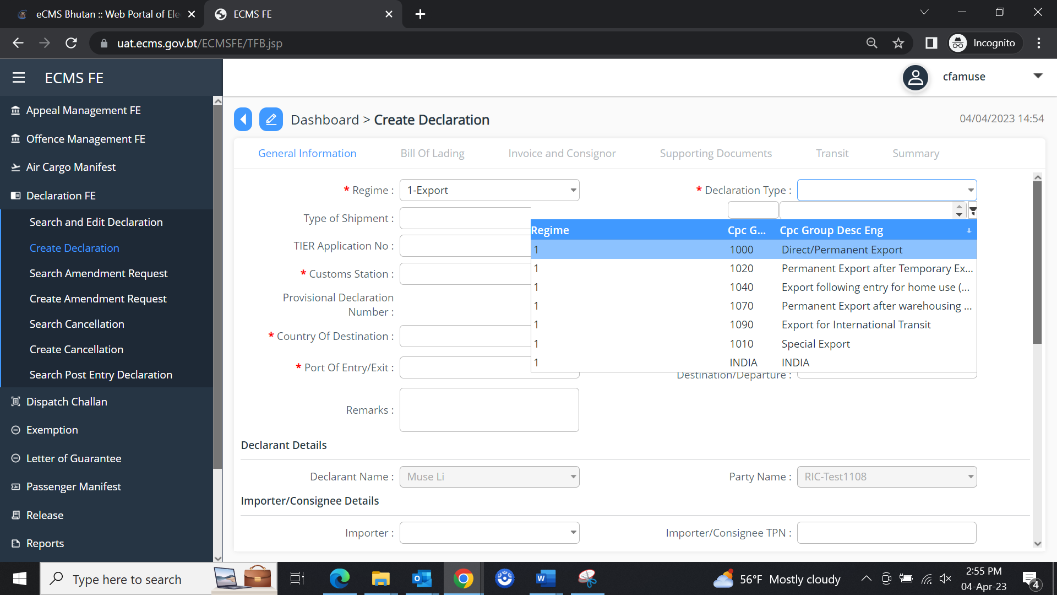

  - Bill of Lading

    - The user needs to add in the Bill of landing wherein we must have Road Manifest details, that has been created and approved before the declaration is created:

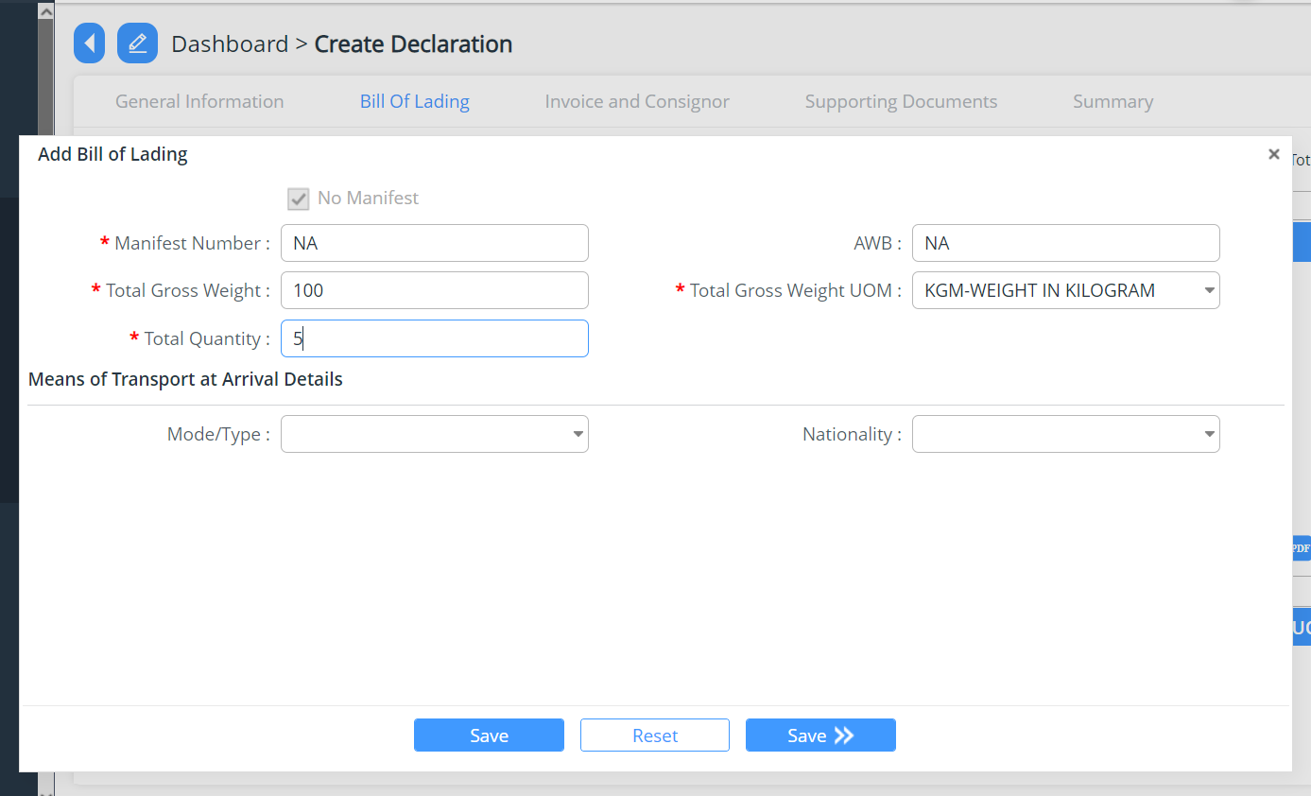

    - At times we have a container associated in the consignment, the details of the container will then have the be added under the Bill of Lading, into the Container details:

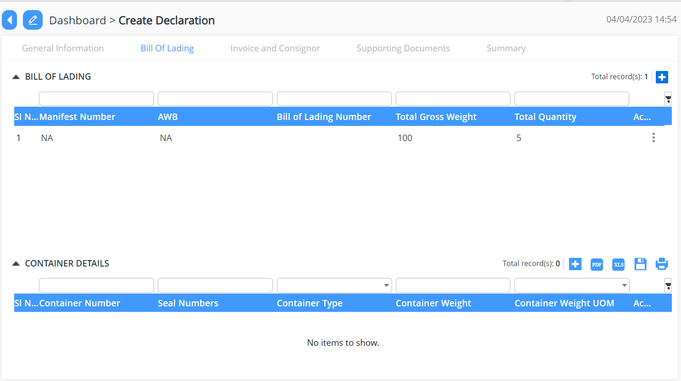

  - Invoice and Consignor

    - Add New invoice and consignor details >> add in the invoice details and commodities details >> Save
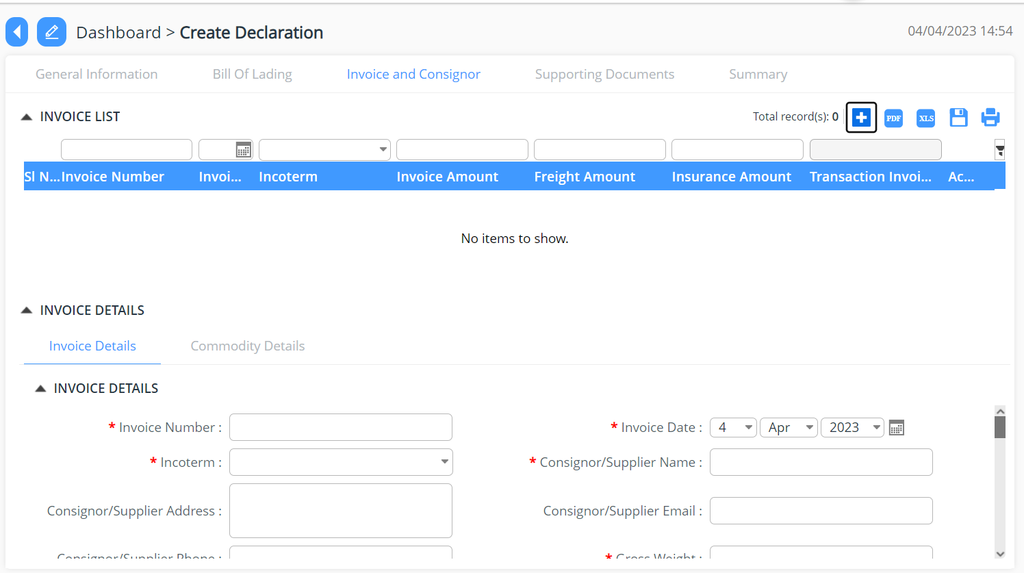

  - Supporting Documents

    - The declarant shall attach mandatory supporting documents (invoice) for approval:

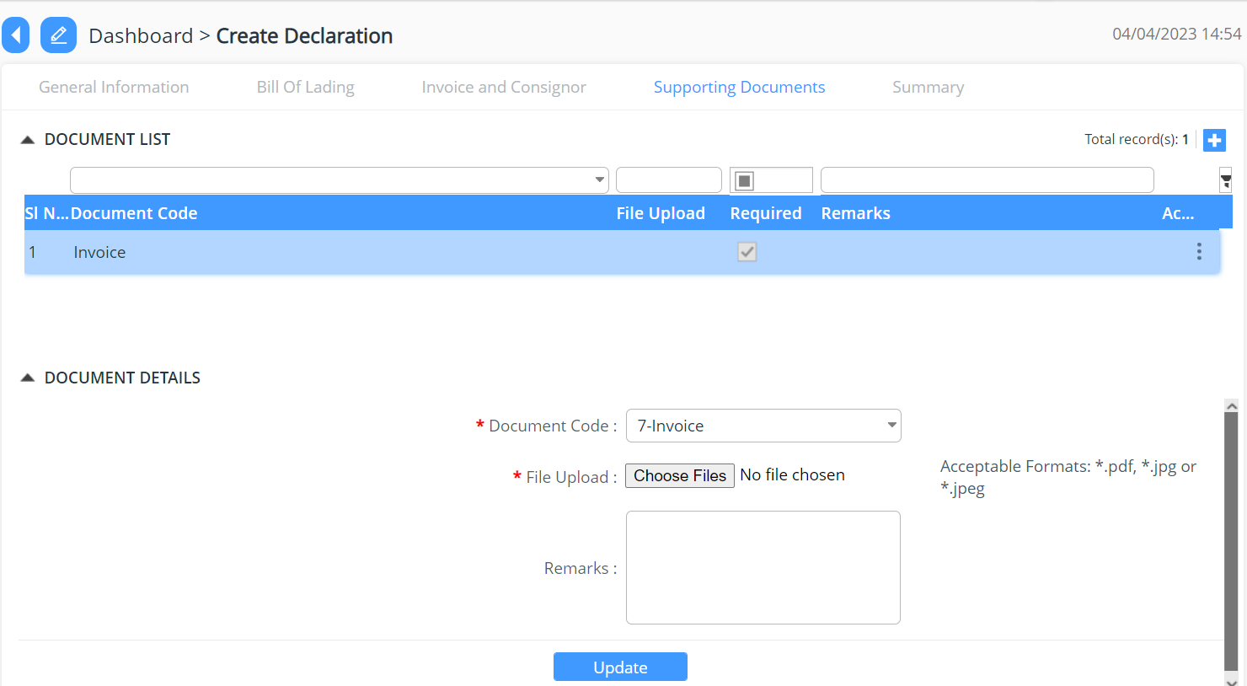

  - Summary

    - The declarant can review his/her declaration summary and submit the same for approval, here we have the check box to accept the terms and condition.
    - Here the user can validate the declaration before submission.
    - The user can submit the declaration which will allow the user to generate the reference declaration number.

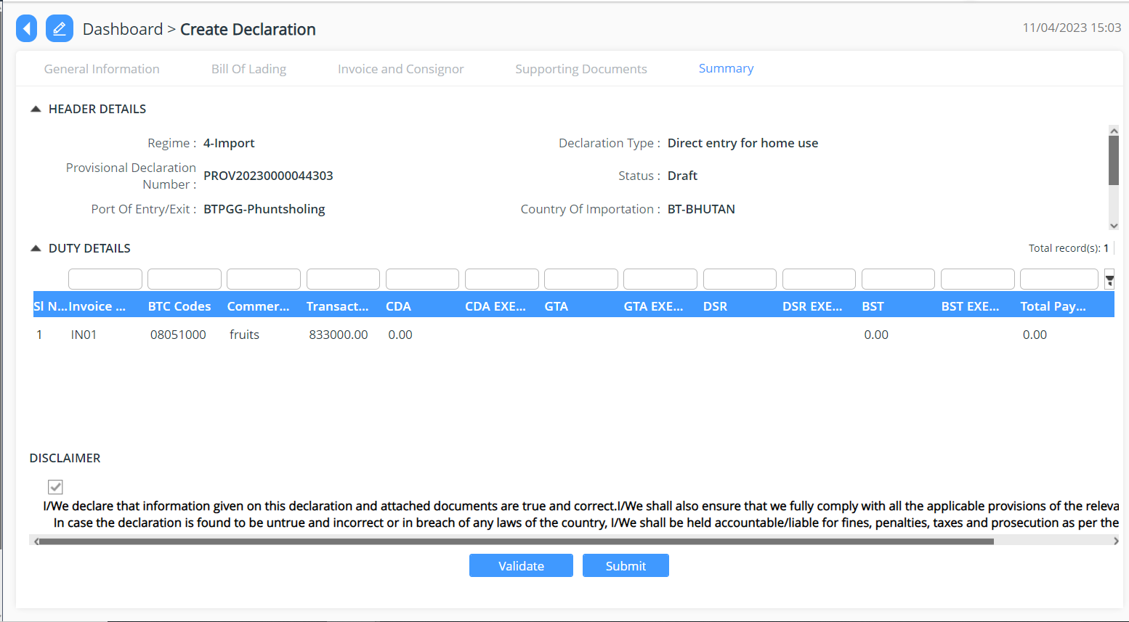

Search Amendment Request
- Provide the list of declaration that has been requested for amendment.

Create Amendment Request
- From the list of declaration, one can request for amendment.
- Click on the declaration for which amendment is required.
- Select the reasons from the dropdown list.
- Provide the remarks for amendment.
- Press submit button.
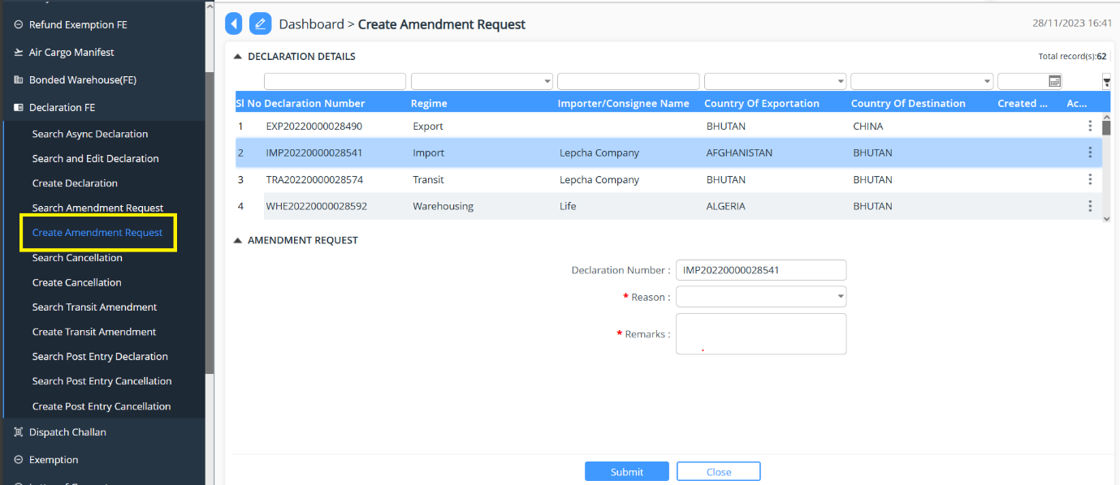

Search Cancellation
- Provide the list of declaration that has been requested for cancellation.

Create Cancellation
- From the list of declaration, one can request for cancellation.
- Click on the declaration for which cancellation is required.
- Select the reasons from the dropdown list.
- Provide the remarks for cancellation.
- Press submit button.
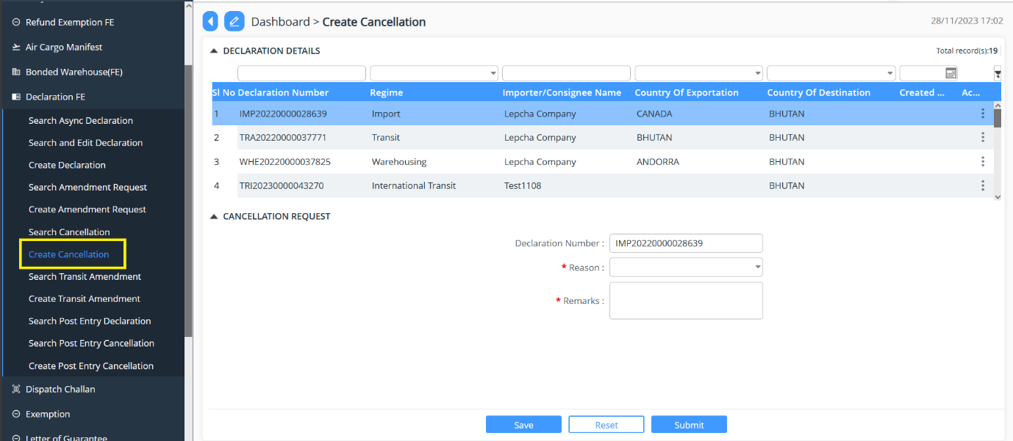

Search Transit Amendment
- Provide the list of declaration with regime Transit that has been requested for amendment.

Create Transit Amendment
- From the list of transit declaration, one can request for cancellation.
- Click on the declaration for which cancellation is required.
- Select the reasons from the dropdown list.
- Provide the remarks for amendment.
- Press submit button.
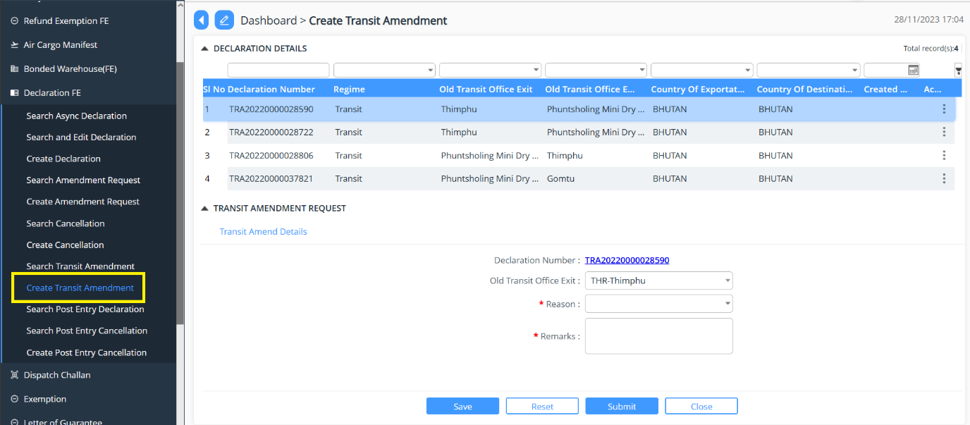

Search Post Entry Declaration
- Provide the list of declaration that has been post entry declaration.

Search Post Entry Cancellation
- Provide the list of declaration that has been requested cancellation of post entry declaration.

Create Post Entry Cancellation
- From the list of declaration, one can request for post entry cancellation.
- Click on the declaration for which cancellation is required.
- Select the reasons from the dropdown list.
- Provide the remarks for cancellation.
- Press submit button

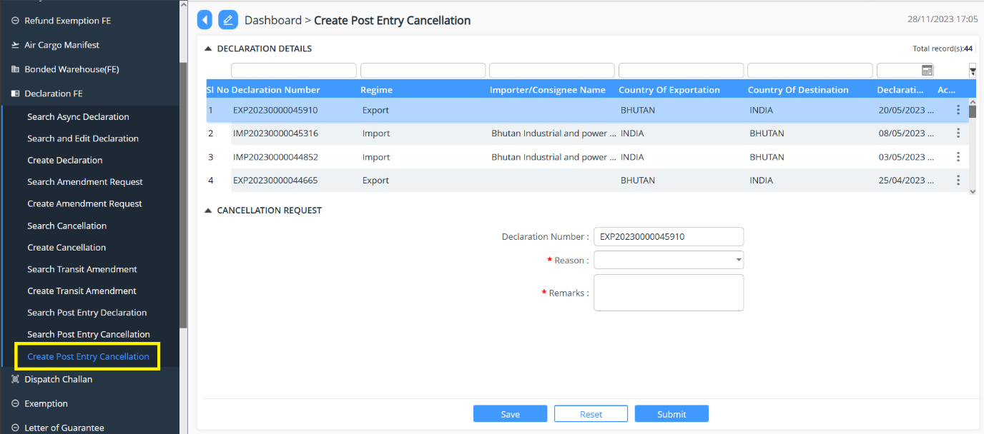

Track Application

- An application Number will be Generated:

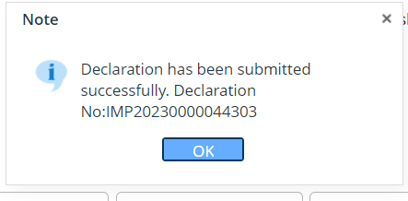

- The users will be able to track their application from Search and Edit Declaration:

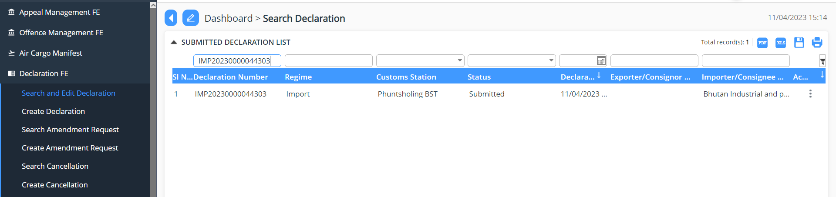

Search amendment request
- User are provided view of the list of declaration that has been for amendment

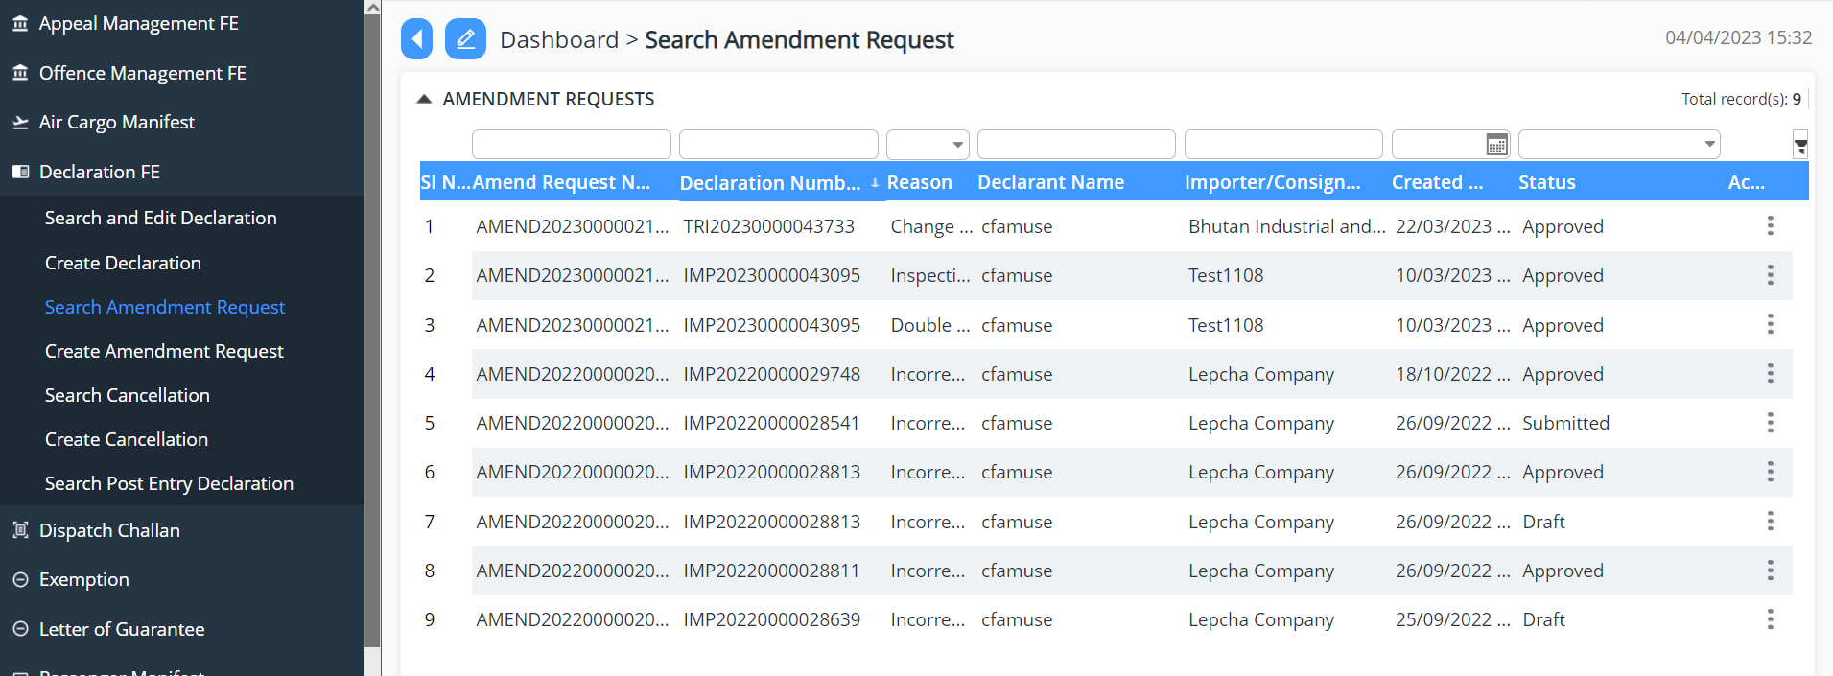

Create Amendment request
- User can request for amendment of declaration that has been submitted.

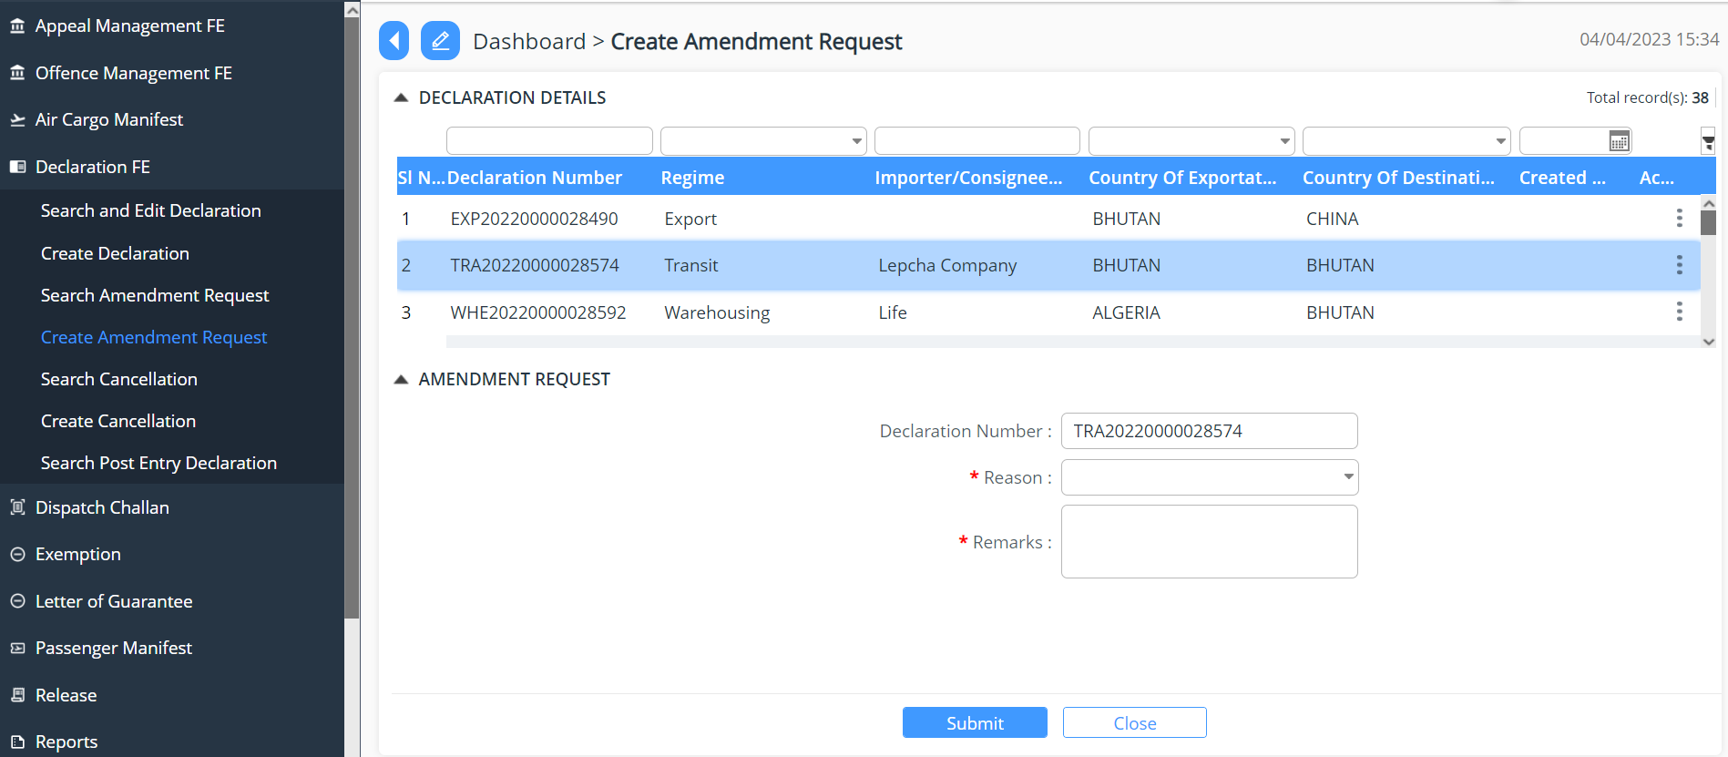

Search Cancellation
- User are provided view of the list of declaration that has been requested for cancellation

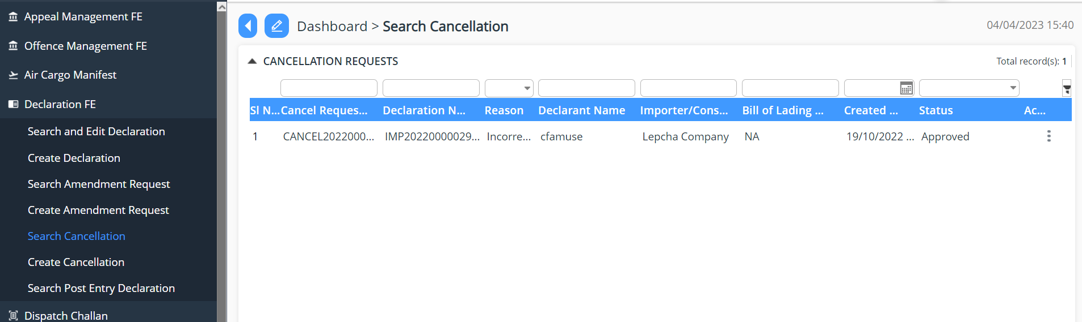

Create Cancellation
- User can create cancellation request for the declaration applied for are provided view of the list of declaration that has been requested for cancellation

